**CITES Scientific Authorities: Checklist to assist in making nondetriment findings for Appendix II exports (IUCN 2002)**

**Table 1 Summary of Harvest Regime for Animal species.**

Tables 1. Animals (1A) and 1. Plants (1P) encourage Scientific Authority staff to make an initial review, at the national level, of the likely effects of harvesting the target species. Information is sought on the types of harvest, the degree of control over the harvest, the segment of the population harvested, the level of total harvest (for domestic and international use), the reason for the harvest, and the end users of the harvest. Scientific Authorities need to distinguish between regulated and illegal or unmanaged harvesting. Consideration of these data will begin or further assist the process of consultation between Scientific and Management Authorities. In the case of some types of harvest, it will also allow the Scientific Authority to advise quickly that harvest is not detrimental to survival.

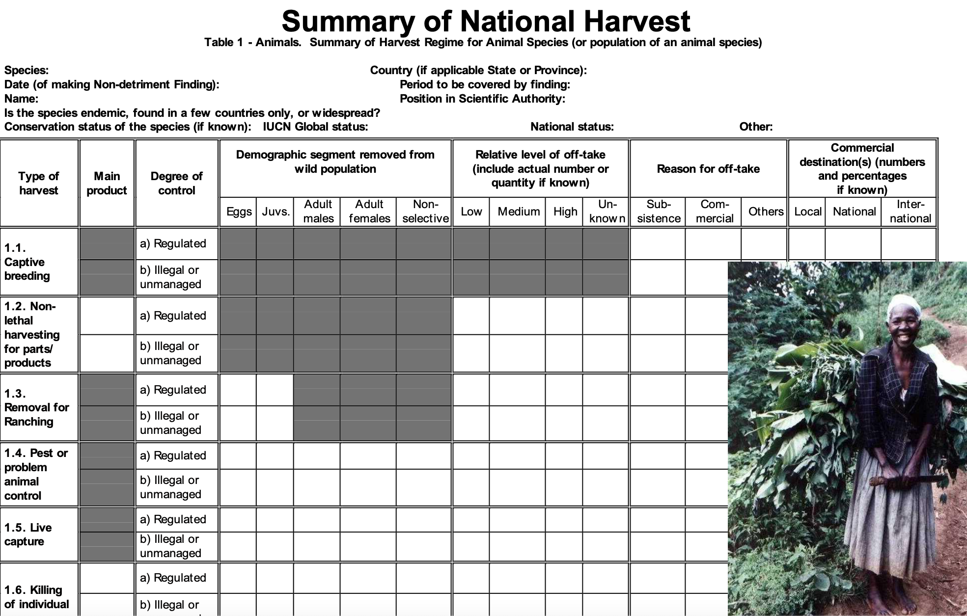

**Table 2. Factors affecting management of the harvesting regime**

Table 2 encourages Scientific Authorities to review in more depth more general biological and management information for those species where Table 1 has raised concerns. Information is also sought on management history and planning, harvest management, status of land on which harvesting takes place, capacity for monitoring the harvest, benefits and risks of harvest, levels of strict protection, and the relationship between ranched and captive-bred specimens to those that are wild caught.

BIOLOGICAL CHARACTERISTICS: ANIMALS ONLY

**2.1 Life history**: Basic life history characteristics indicate the likely sensitivity of a species to harvest. For 60 example, r-selected species (“r-strategists”) with a high intrinsic rate of increase are likely to be at less risk from harvest than K-selected species (“K-strategists”), which mature slowly and have low reproductive rates (e.g., mice versus elephants, starlings versus raptors).

**2.2 Ecological adaptability**: Ecological adaptability indicates the likely sensitivity to harvest and encompasses factors such as the species’ breadth of habitat use, dietary breadth, and environmental tolerance (in other words, niche breadth). These factors are divided into the broad categories of generalist or specialist. Generalists can switch prey or habitat types relatively easily and are likely to be less affected by disturbances in their range than specialists that occupy a narrow ecological niche. A specialist with a low level of ecological adaptability is somewhat more likely to be negatively impacted by harvest for trade than a generalist (though not in all cases). For example, a given predator population at the top of a food chain, is likely to be more sensitive to harvest than a given herbivore population, lower in the food chain.

**2.3 Dispersal efficiency:** Species which have mechanisms that ensure a wide dispersal of individuals during some part of their life history may be less susceptible to the effects of harvest than similar species (depending on the life history of the species). Such species can more easily recolonize areas from which they have been locally extirpated. For example, a number of marine organisms depend on the dispersal of large numbers of widely distributed planktonic larvae, and so may be able to recolonize habitats from which the more sedentary adults have been overfished e.g. giant clams.

**2.4 Interaction with humans**: The tolerance of a species to human activity may indicate its likely sensitivity to the effects of harvest. Species mostly tolerant of human intervention are also likely to be the least affected by harvest. Pests, which people have difficulty in eradicating, and commensal species that benefit from the spread of human-induced environments such as agricultural land, are likely to be least sensitive to harvest. For example modified habitats in oil palm plantations in Indonesia support much higher populations of rodent prey and consequently of blood pythons than an equivalent area of natural habitat (although other species found in undisturbed habitats are absent from the oil palm plantations).

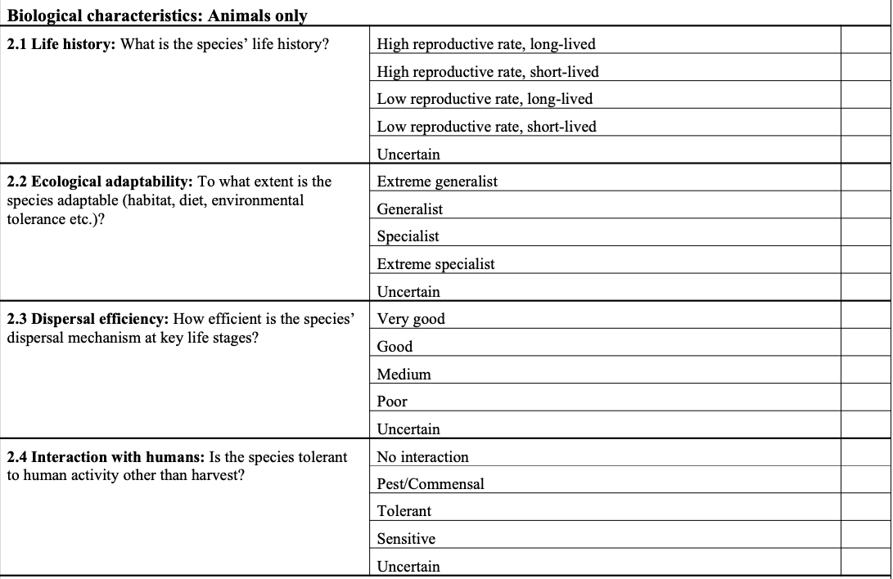

NATIONAL STATUS

**2.5 National distribution**: The pattern of distribution of a species provides some indication of a species’ sensitivity to harvest. Widespread species with a continuous distribution at the national or regional level are likely to be less sensitive to harvest or other threatening factors than species with a widespread but fragmented distribution. Population fragmentation may produce sub-populations, adapted to a specialized or restricted habitat, that are too small to be viable. Localized endemic species adapted to specific habitats that are naturally fragmented, such as mountain chains, are more likely to be at risk from habitat change and the effects of harvest. Species that are localized nationally, i.e. only occur in a few locations at the national level, could be particularly at risk from unmanaged harvest.

2**.6 National abunda**nce: Intuitively, species that are generally very abundant and occur at high densities are likely to be less sensitive to harvest than less common species occurring at naturally low densities. However, some species that occur at high densities are prone to major fluctuations in population size, either on a regular basis or due to stochastic events, and the impact of harvest in a climatically bad year (for the species) may result in a large population reduction from which the species cannot recover rapidly, (e.g. Saiga antelope). For species that are already uncommon or rare, the margin of error associated with the harvest is likely to be low. For example, predators are generally less numerous than prey species, or mahogany trees are generally less numerous than daisies.

**2.7 National population trends**: Trends in national population status provide some indication about a species’ likely susceptibility to harvest: species with an increasing population are likely to be less sensitive to harvest than species whose population is decreasing. Ideally, trends in the national population status should be measured over a time period independent of the harvest regime, and should recognise the “shifting baseline” phenomenon, in which each manager takes the population level first encountered as the baseline level. This phenomenon is very important for a species or population that has experienced a history of harvest and commercial use. Mathematical modelling suggests an independent time period of three generations is necessary as a minimum. However, generation time is not known accurately for a number of species in trade and, in these cases generation time should be predicted, based on known biological information from closely related species. If data from actual population surveys are available, ideally results from a minimum of three censuses should be used to evaluate trends. As population monitoring improves, the age and sex structure of the population should also be assessed. Failing this, trends in measures or indices of relative abundance can also be used. In the absence of such data from the field, indices of habitat loss can be used to infer whether populations are likely to be declining.

**2.8 Quality of information**: The quality of data used to describe population trends is an important consideration in determining the robustness of the advice on non-detriment findings. For example, if all the data presented are recent and quantitative, then the confidence in the results of the assessment will be high. In contrast, if the majority of data are anecdotal, the chance of making a robust non-detriment finding will be lower. Consequently, more emphasis is placed on good local qualitative knowledge than on out-of-date quantitative data.

**2.9 Major threats**: Assessing the severity of the impact of the major threat provides a basis to weigh up the relative impact of the harvest. The major threat to the species at the national level should be indicated in the left-hand box and the severity of the threat recorded in the relevant right-hand box. For example, if habitat loss is the major threat and its impact on the species is severe and irreversible, then it may be difficult to justify a harvest at all from an area not affected by the habitat destruction. In contrast, if the effects of habitat loss are reversible, a well regulated harvest could possibly provide incentives to reverse the habitat loss (see also 2.13). It is vital to any evaluation of non-detriment that the Scientific Authority assesses the impact of trade in relation to other threats to the species.

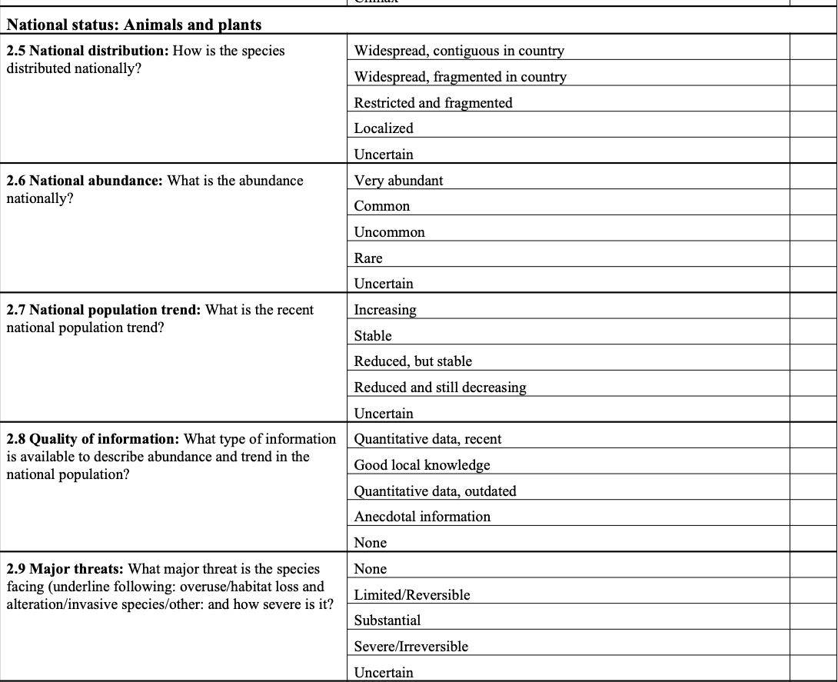

HARVEST MANAGEMENT

**2.10 Illegal harvest or trade**: The total harvest to which a population is subject at the national level must be considered in assessing the impacts of a harvest. Consequently, it is necessary to try to assess the levels of both unmanaged and illegal harvest, even though reliable information is particularly difficult to collect (see also Tables 1A and 1P). Nonetheless, managers can often make an intuitive assessment of the significance of such harvest, in relation to the level of regulated legal harvest. Good local information and information from rangers and other enforcement personnel in the field is often exceedingly useful in evaluating the level of illegal harvest.

**2.11 Management history**: The management history of a harvest provides a good starting point to assess the likely sustainability of the harvest. A harvest with a long history of effective management, particularly wellregulated adaptive management, is more likely to be sustainable than an unmanaged harvest. A managed harvest, with adaptive management based on reliable monitoring of how harvest affects the population is the optimum situation. A managed harvest is one in which there is some degree of oversight and feedback, whether it be under a formal or an informal process. Any harvest regime necessarily contains an element of experiment, and requires feedback and monitoring for absolute safety. An ongoing but informally managed harvest may not have a nationally approved structure, but may nonetheless have a good chance of sustainability, particularly if associated with strong local resource ownership. In contrast, the necessary feedback will not have taken place in a newly established programme of harvest, so the probability of sustainability may still be open to question. An unmanaged harvest is one in which there is no oversight and the harvest is taken in a purely opportunistic manner, giving least confidence in its sustainability.

**2.12 Management plan or equivalent**: The development and adoption of a national management plan or equivalent is necessary to build the political will to establish the process of sustainable use. Furthermore, a harvest managed according to a nationally approved management plan is likely to have undergone a process of review and scrutiny before official adoption, and should thus have a higher chance of reliability. Ideally national management plans should be developed in conjunction with local inputs, because the majority of harvested species are likely to be patchily rather than uniformly distributed throughout a range State, and so any harvest should be managed at the local level to avoid local extirpations. In range States with a strong federal/state or provincial system, strong management plans at the state or provincial level would be the equivalent of strong national management plans. Consequently, the optimum harvest management situation will include approved and co-ordinated local and national management plans. In cases where there is no approved plan and informal or unplanned management takes place, there will be little confidence in the probability that the harvest is sustainable or that the export is non-detrimental.

**2.13 Aim of harvest regime in management planning**: The aim of the harvest regime for a species has a considerable bearing on the probability that a harvest will be sustainable. Where the main aim is to generate conservation benefits, particularly on a habitat or ecosystem level, the likelihood that the harvest will not be detrimental to the wild population should be higher. For example, the encouragement of butterfly farming in Irian Jaya, Indonesia, was promoted to provide an economic incentive to maintain the natural vegetation that supports the butterfly populations. Where control of the target population is the aim, the rationale is that a managed situation is better in conservation terms than an unmanaged situation. For example, people may be more likely to tolerate crocodilians, and their habitats, if there is some visible form of management and protection of human life and economic returns. Where the aim is to maximize economic yield, the sustainability of the programme will have a lower probability, depending on the long-term strategy. Whilst maximum short-term economic yield derives from mining the resource completely, a strategy to maximize economic yield in the long-term should result in a more sustainable programme. Although this may only be true in theory, and in many cases harvesting is opportunistic and unselective, giving the low confidence in the sustainability of the harvest. Mining of the resource to commercial near extinction is often the result, followed by exploitation of other species.

**2.14 Quotas:** Quotas have been used as a means of regulating and managing harvests for some time, and export quotas have become increasingly common in CITES as questions have been raised about particular harvest regimes. As in the adoption of management plans (2.12), the optimum situation is one in which: a) a national quota is based on local quotas that guard against local overexploitation, and b) the quota is based on knowledge of species’ biology, life history, demographics, and reproductive capacity. Quotas can be based on the numbers of individuals removed from the wild, or on specific age or size classes within the population. A well managed, biologically-based harvest programme may involve harvest only of immature animals or plants, depending on the life history of the species concerned. For many species in trade detailed biological information is not readily available, so a system of “cautious”, co-ordinated local and national quotas may be adopted. “Cautious” national quotas are those which are very small relative to the likely national population size. Finally, untried local quotas based on a biological understanding of the species would be expected to give a higher chance of sustainability than a situation in which market driven, arbitrary or no quotas are set. “Market driven” describes the situation in some countries where the traders are able to demand a given quota, or quotas are assigned based on expected commercial demand. An arbitrary quota is one based on no apparent knowledge of the species.

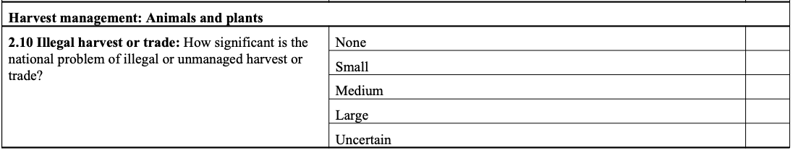

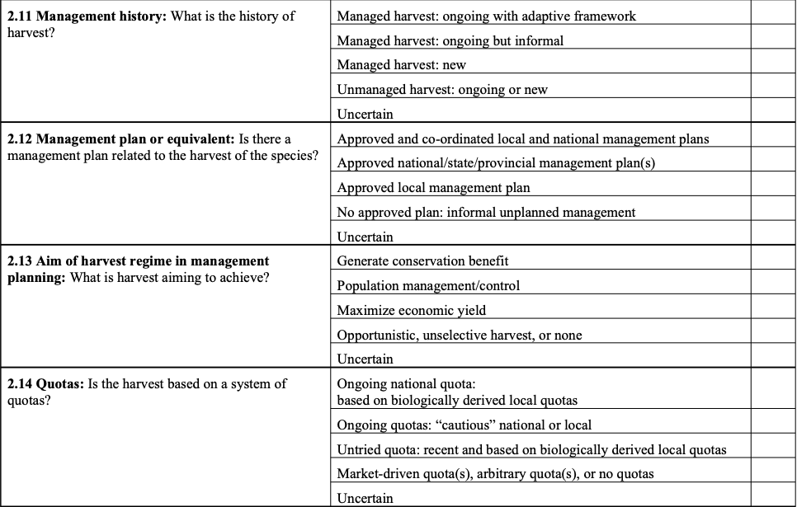

CONTROL OF HARVEST

**2.15 Harvesting in Protected Areas (PA**): Resource ownership and tenure can play an important role in determining the sustainability of harvests. If tenure and ownership are strong, the incentive for good management and regulation is likely to be greater. Protected areas have a variety of designations and purposes, depending on the national legal and political systems in place. The term, State Protected Area is here used to encompasses a variety of PAs and multiple use zone types, where sustainable use and harvest are allowed, including forest, game and marine reserves, and socalled “National Parks” in China and UK. Range States may have several types of such PAs which offer different degrees of protection from harvest. In general, greater confidence can be placed in the likely sustainability of the harvest if most of it occurs either in such State PAs or in other areas with strong tenure (see also 2.16).

**2.16 Harvesting in areas with strong resource tenure or ownership**: Strong local control over resource use may range from the local community management or private land management systems in place in southern Africa to the strong local control practised by communities surrounding oil palm plantations in Indonesia, where blood pythons are harvested. In all these cases either a local community or a private landowner is responsible for managing and regulating the harvest. In such systems, it is generally thought to be in the longterm best interests of those who own the resource to ensure that it is used in a sustainable manner. Consequently, greater confidence will be placed in the likely sustainability of the harvest if most harvest occurs in areas with strong resource ownership (see also 2.15).

**2.17 Harvesting in areas with open access:** When there is neither strong state, nor community, nor private 63 tenure, a system of open access prevails. In such cases there is no local control over the resource and a danger that there will be no incentive to regulate the harvest, resulting in a “free for all”. Little confidence can be placed in the sustainability of harvest if most occurs in areas with actual or de facto open access.

2**.18 Confidence in harvest management:** This question requires a judgement on the effectiveness of harvest controls. A variety of factors such as low budgets, lack of trained staff, other capacity deficiencies, or a lack of political will, may prevent harvest controls from being implemented adequately. A response that indicates a lack of confidence in harvest management should not be seen by the respondent as an indictment of his/her government, but rather a recognition of existing deficiencies.

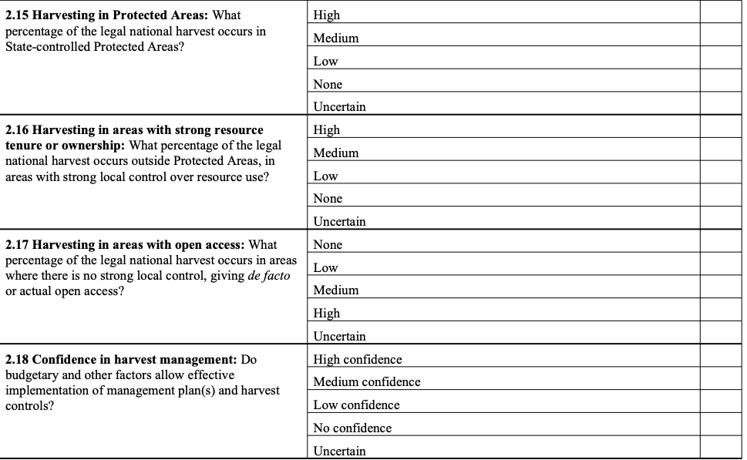

MONITORING OF HARVEST

**2.19 Methods used to monitor harvest:** Monitoring of the harvest is vital and essential to ensuring the sustainability of any harvest. Direct population estimates of the harvested population or other measures of absolute density or abundance are generally considered the best methods, but may be very expensive and time consuming to implement, or may be impossible for the species concerned for biological reasons. In the absence of direct population measures, quantitative indices of population abundance and trend (measures of relative density or abundance) of the harvested population can be used. Alternatively qualitative indices may be used, which, if based on good local knowledge, can provide good indications of the effects of harvest. Under CITES, all Scientific Authorities are required to monitor exports, so that these can be halted or reduced if levels are thought to be detrimental to the survival of species, or the species is being used at a level inconsistent with its role in its ecosystem. CITES Annual Report data can play a very important role in monitoring, and better use of these data, along with better communication between Scientific Authorities of different countries, would allow Scientific Authorities to build up increasingly accurate pictures of the effects of international trade on population trends. This question could receive multiple ticks in answer, but only the most effective/principal monitoring system should be scored.

**2.20 Confidence in harvesting monitoring**: This question requires a judgement on the effectiveness of the monitoring system in use. For example a Scientific Authority may know that direct population estimates are conducted, but that budgetary, staffing and other resource constraints result in such population counts only being conducted at long intervals, insufficient to monitor the effects of an annual harvest programme. A response that indicates a lack of confidence in harvest monitoring should not be seen by the respondent as an indictment of his/her government, but rather a recognition of existing deficiencies.

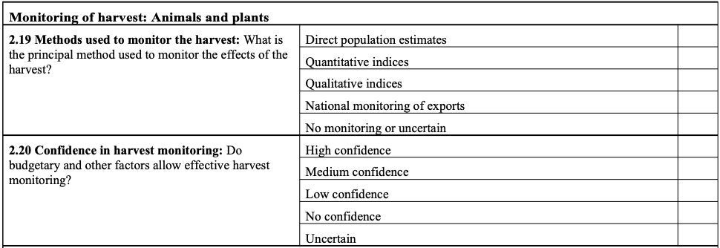

INCENTIVES AND BENEFITS FROM HARVESTING

**2.21 Use compared with other threats**: The major threat to the species was identified in 2.9, and this question aims to determine how use affects the species in relation to the major threat affecting the species. In some cases, use of the species may convey conservation benefits that mitigate the effects of some other major threat such as habitat destruction. In other cases, use does not affect the species detrimentally and does not have any mitigating effects on other major threats, so any use has a neutral effect. Thereafter, the harvest may become increasingly harmful in conjunction with the major threats. In yet other cases, the use may exacerbate other threats (such as disease, invasive species, or habitat deterioration), thereby necessitating a more cautious or precautionary non-detriment finding. The nondetriment finding should never be taken out of context from other impacts and conservation benefits impinging on the species.

**2.22 Incentives for species conservation:** In some rare cases the species derives a direct benefit from the harvesting programme. In many cases, the benefit may not be financial, but in such cases, the harvest programme may significantly reduce illegal collection.

**2.23 Incentives for habitat conservation**: This question looks at the broader implications of harvest to support habitat conservation. Any potential benefit to habitat conservation should be known and demonstrated. If a benefit is intended but it cannot be shown, this question should be answered as “low”. If no conservation benefit is intended, this question should be answered “none”.

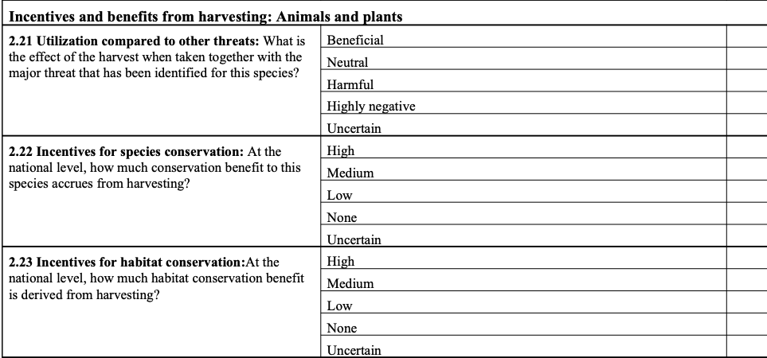

PROTECTION FROM HARVEST

**2.24 Proportion strictly protected from harvest**: Strict protection, both legally and in practice, of representative parts of a species’ range, or of a portion of the population sufficient to ensure its survival, should prevent harvest threatening the whole national population of a species. This question aims to assess the percentage that is strictly protected (where strict protection is defined as a prohibition on removal from the wild). For many species, the existence of strict protected areas where harvest is not allowed, with adequate enforcement controls, is an important assurance that core areas can provide recruitment to a population subject to harvest.

2**.25 Effectiveness of strict protection measures:** This question requires an assessment of the effectiveness of protection measures. A number of factors including budgets and the resource ownership of such protected areas may have a bearing on how effective they are. A response that indicates a lack of effectiveness of strict protection measures should not be seen by the respondent as an indictment of his/her government, but rather a recognition of existing problems and challenges.

**2.26 Regulation of harvest effort:** This question requires an assessment of the effectiveness of harvest restrictions. These restrictions generally comprise closed seasons, or portions of the population which cannot be targeted (based on size, for example). Much of the success of these measures will depend on the political will for enforcement and on the degree to which harvesters are law-abiding.

